## CHANDIGARH UNIVERSITY

## UNIVERSITY INSTITUTE OF NGINEERING

**DEPARTMENT OF COMPUTER SCIENCE & ENGINEERING**



|  |  |
| --- | --- |
| **Submitted By: Submitted To:**  Vivek Kumar(21BCS8129) Er. Himanshi (13362) | |
| **Subject Name** | Web and Mobile Security Lab |
| **Subject Code** | 20CSP-338 |
| **Branch** | Computer Science and Engineering |
| **Semester** | 5th |

**Experiment - 8**

**Student Name: Vivek Kumar UID: 21BCS8129**

**Branch: BE-CSE(LEET) Section/Group: WM-20BCS-616/A**

**Semester: 5th Date of Performance: 02/11/2022**

**Subject Name: Web and Mobile Security Lab Subject Code: 20CSP-338**

1. **Aim/Overview of the practical:**

Write a program to sign and verify a document using DSA algorithm.

1. **Task to be done/ Which logistics used:**

To generate the concept of digital signature

**3. Apparatus / Simulator Used:**

* Windows 7 & above version.
* Google Chrome C/C++
* Java
* Python platform

**Discussion:**

The digital signature is a mechanism that verifies the authority of digital messages as well as documents. It is very popular because it provides more security than other signatures. In Java, JDK Security API is used to create and implement digital signatures. In this section, we will discuss the digital signature mechanism and also implement the digital signature mechanism in a Java program.

The digital signature is an electronic signature to sign a document, mail, messages, etc. It validates the authenticity, and integrity of a message or document. It is the same as a handwritten signature, seal, or stamp. It is widely used to verify a digital message, financial documents, identity cards, etc.

In short, we can say that it en ures the following:

o Integrity: It ensures the message or a document cannot be altered while transmitting.

o Authenticity: The author of the message is really who they claim to be.

o Non-repudiation: The author of the message can't later deny source.

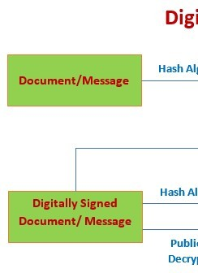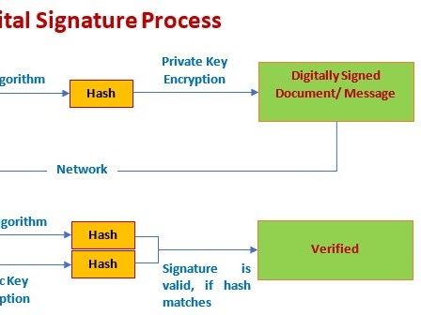

**4. Program/ Steps/ Method:**

import java.io.*;

import java.security.*;

public class GenerateDigitalSignature {

public static void main(String args[]) {

/* Generate a DSA signature */

if (args.length != 1) {

System.***out***.println("Usage: nameOfFileToSign");

} else

try {

/* Generate a key pair */

KeyPairGenerator keyGen = KeyPairGenerator.*getInstance*("DSA", "SUN");

SecureRandom random = SecureRandom.*getInstance*("SHA1PRNG", "SUN");

keyGen.initialize(1024, random);

KeyPair pair = keyGen.generateKeyPair();

PrivateKey priv = pair.getPrivate();

PublicKey pub = pair.getPublic();

/* Create a Signature object and initialize it with the private key */

Signature dsa = Signature.*getInstance*("SHA1withDSA", "SUN");

dsa.initSign(priv);

/* Update and sign the data */

FileInputStream fis = new FileInputStream("R:\\VnjVibhash\\Assignments\\CU-Assignments\\5th Sem\\Java\\JavaLab\\src\\Input.txt");

BufferedInputStream bufin = new BufferedInputStream(fis);

byte[] buffer = new byte[1024];

int len;

while (bufin.available() != 0) {

len = bufin.read(buffer);

dsa.update(buffer, 0, len);

}

;

bufin.close();

/*

* Now that all the data to be signed has been read in, generate a signature for

* it

*/

byte[] realSig = dsa.sign();

/* Save the signature in a file */

FileOutputStream sigfos = new FileOutputStream("F:\\Digital Signature Demo\\signature.txt");

sigfos.write(realSig);

sigfos.close();

/* Save the public key in a file */

byte[] key = pub.getEncoded();

FileOutputStream keyfos = new FileOutputStream("F:\\Digital Signature Demo\\publickey.txt");

keyfos.write(key);

keyfos.close();

} catch (Exception e) {

System.***err***.println("Caught exception " + e.toString());

}

};

}

**Output:**

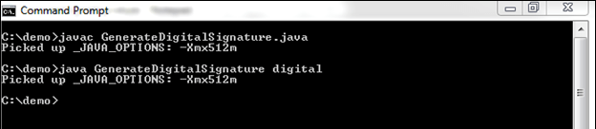

**5. DBMS Script/Result/Output/Writing Summary:**

import java.io.*;

import java.security.*;

import java.security.spec.*;

public class VerifyDigitalSignature {

public static void main(String args[]) {

/* Verify a DSA signature */

if (args.length != 3) {

System.***out***.println("Usage: publickeyfile signaturefile datafile");

} else

try {

/* import encoded public key */

FileInputStream keyfis = new FileInputStream("F:\\Digital Signature Demo\\publickey.txt");

byte[] encKey = new byte[keyfis.available()];

keyfis.read(encKey);

keyfis.close();

X509EncodedKeySpec pubKeySpec = new X509EncodedKeySpec(encKey);

KeyFactory keyFactory = KeyFactory.*getInstance*("DSA", "SUN");

PublicKey pubKey = keyFactory.generatePublic(pubKeySpec);

/* input the signature bytes */

FileInputStream sigfis = new FileInputStream("F:\\Digital Signature Demo\\signature.txt");

byte[] sigToVerify = new byte[sigfis.available()];

sigfis.read(sigToVerify);

sigfis.close();

/* create a Signature object and initialize it with the public key */

Signature sig = Signature.*getInstance*("SHA1withDSA", "SUN");

sig.initVerify(pubKey);

/* Update and verify the data */

FileInputStream datafis = new FileInputStream("F:\\Digital Signature Demo\\digital.txt");

BufferedInputStream bufin = new BufferedInputStream(datafis);

byte[] buffer = new byte[1024];

int len;

while (bufin.available() != 0) {

len = bufin.read(buffer);

sig.update(buffer, 0, len);

}

;

bufin.close();

boolean verifies = sig.verify(sigToVerify);

System.***out***.println("signature verifies: " + verifies);

} catch (Exception e) {

System.***err***.println("Caught exception " + e.toString());

}

;

}

}

**Output:**

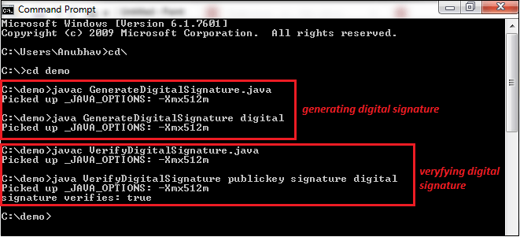

**Learning outcomes (What I have learnt):**

With this, you have understood the importance of asymmetric cryptography, the working of digital signatures, the functionality of DSA, the steps involved in the signature verification, and its advantages over similar counterparts.

**Evaluation Grid (To be created per the faculty's SOP and Assessment guidelines):**

|  |  |  |  |
| --- | --- | --- | --- |
| Sr. No. | Parameters | Marks Obtained | Maximum Marks |
| 1. | Worksheet completion including writing learning objectives/Outcomes.  (To be submitted at the end of the day). |  |  |
| 2. | Post-Lab Quiz Result. |  |  |
| 3. | Student Engagement in  Simulation/Demonstration/Performance and Controls/Pre-Lab Questions. |  |  |
|  | Signature of Faculty (with Date): | Total Marks Obtained: |  |